GalvAnalyze User Guide

GalvAnalyze is a tool created to simplify the analysis of galvanostatic charge-discharge cycling for battery research scientists. A compiled executable is available for download from the Nottingham Applied Materials and Interfaces group website (https://www.thenamilab.com/about-4) in a plug-and-play format. The Python source code is available on GitHub (https://github.com/LukasRier/GalvAnalyze) where further development and contributions to the code are encouraged.

Downloading GalvAnalyze

The source code can be accesses on GitHub as mentioned above.

To download the GalvAnalyze executable (recommended for those without experience of using the python programming language), go to https://www.thenamilab.com/about-4, scroll to the bottom of the page and click the “Download GalvAnalyze” button. This will begin the download of a zipped file containing the executable. NOTE: this file is ~45 MB, ensure that you have sufficient space on your hard drive.

Once downloaded, the executable can be run from within the zipped folder. Upon opening of the executable, Windows Defender SmartScreen may declare that this is an “unrecognized app”. To bypass this, press “More Info” and then “Run anyway”.

Should you deem this unsuitable, the source code can be gathered from GitHub and you can generate your own executable by following the step-by-step guide given in the README section https://github.com/LukasRier/GalvAnalyze/blob/main/README.md.

GalvAnalyze is provided by the authors “as is” and “with all faults”. The authors make no representations or warranties of any kind concerning the safety, suitability, lack of viruses, inaccuracies, typographical errors, or other harmful components of GalvAnalyze. There are inherent dangers in the use of any software, and you are solely responsible for determining whether GalvAnalyze is compatible with your equipment and other software installed on your equipment. You are also solely responsible for the protection of your equipment and backup of your data, and GalvAnalyze will not be liable for any damages you may suffer in connection with using, modifying, or distributing GalvAnalyze.

Data pre-requisites

The executable reads the column headings from the user selected text file. In order for the code to read the data, these column headings must match those that have been pre-written into the code. These headings must match exactly including spaces - if these headings are not found, the script will encounter an error.

Potential: “Ecell/V”, “E /V”, “Ewe/V”, “E/V”, “Voltage/V” or “Voltage(V)”
Current: “<I>/mA”, “I /mA”, “I/mA”, “Current/mA”, or “Current(A)”
Time: “time/s” or “time /s”

Once this data is read into the script, the raw inputs are used to calculate capacity passed, separate charge and discharge cycles, and complete numerical and graphical analysis.

Example Scenarios

2 test datasets are available in both the GitHub repository and on the NAMI website. Here we will walk through 5 data scenarios using these datasets as a user guide.

Scenario 1: Base functionality
The base functionality of GalvAnalyze is set up to handle a dataset where the magnitude of the applied current is constant and the first process is battery charging. If your dataset matches both of these criteria, the base functionality will allow you to process your data. This scenario will use test case “Case1_ActiveMass_18mg_CurrentThreshold_0.15mA” assuming that we meet both of these criteria.

When the GalvAnalyze executable is opened, you will be presented with a user interface that looks like this:

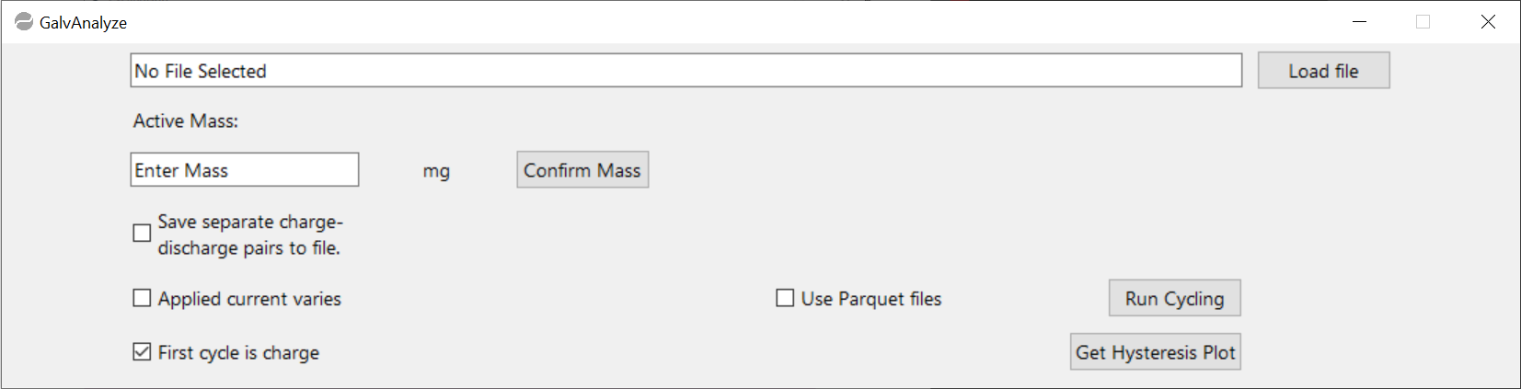

To load a .txt file into the executable, use the “Load file” button.

NOTE: please check that the column headings of the text file match the pre-requisites listed above.

When the file has been selected, a pop-up window will show the read data and the positions of the automatic threshold that will be applied unless the user defines their own threshold, and the filename will populate the top text box. An example of these are shown below for test case 1. You are then required to enter your active mass, which here is 18 mg. Once entered, press the “Confirm Mass” button.

NOTE: if you do not enter a mass, you will be prompted to enter one before analysis proceeds.
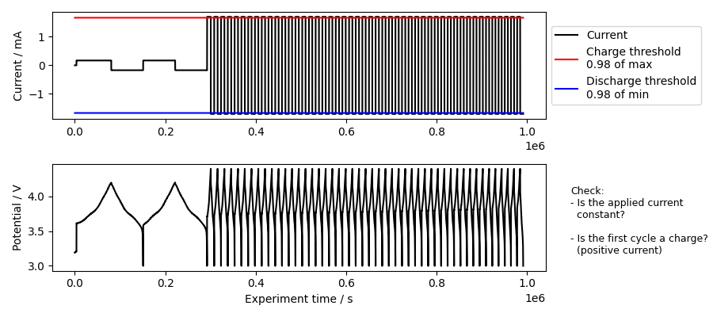
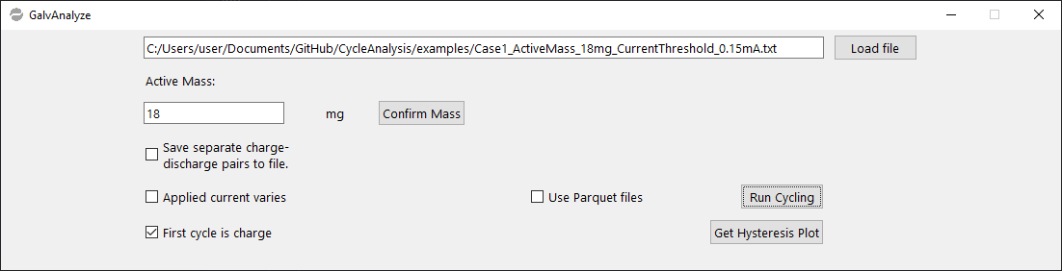

Once the file has been loaded and the active mass has been accepted, press the “Run Cycling” button and the data processing will proceed, resulting in the generation of the figures and files shown below. The top three figures represent the processed data, showing from left to right a capacity vs. cycle number, voltage profiles vs capacity, and the first cycle hysteresis. The diagnostic figure below this shows the applied threshold, with red and green regions indicating the regions that GalvAnalyze has identified as part of a charge (green) and discharge (red) region.
NOTE: Files will only be exported in a parquet file format if the “Use Parquet files” option is selected.
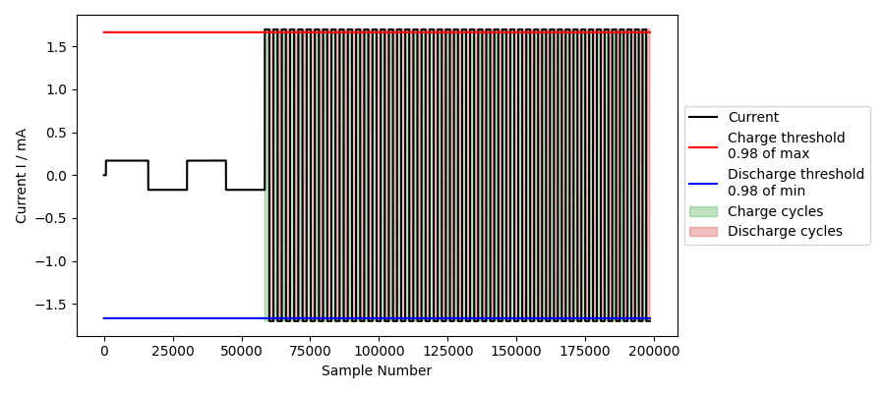
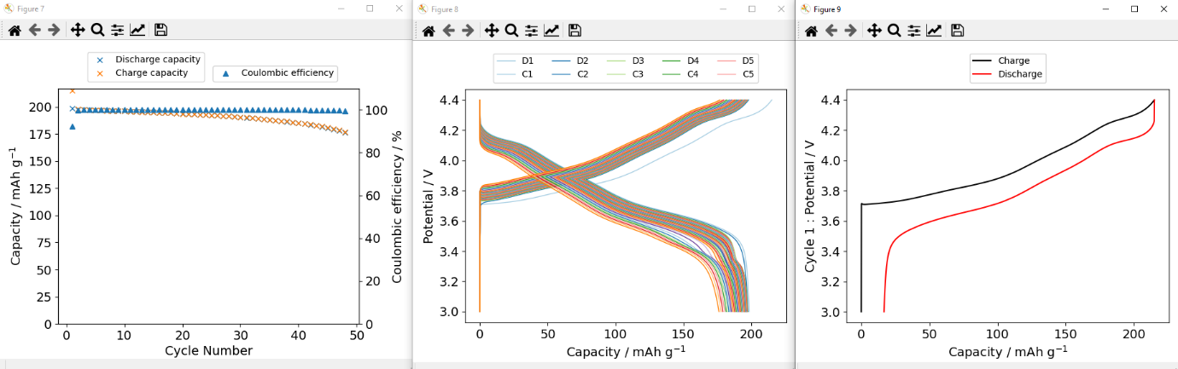

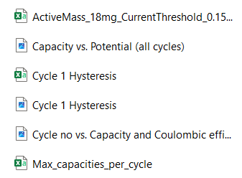
The outputs are contained in a folder with the format [filename]_OUTPUTS, which for this case is “Case1_ActiveMass_18mg_CurrentThreshold_0.15mA_OUTPUTS. The files procedure by running the above scenario are shown below.

The raw data for the “Capacity vs. Potential (all cycles)” figure is contained in the “[filename]” output which contains all of the data separated into charge cycles and discharge cycles. This data can be simplified greatly by following scenario 4 if this data needs to be re-plotted.

The “Cycle 1 Hysteresis” file contains the raw data for re-plotting the “Cycle 1 Hysteresis” figure.

The “Max_capacities_per_cycle” file contains the raw data for re-plotting the “Cycle no vs. Capacity and Coulombic efficiency” figure.

NOTE: Parquet files will only appear if the “Use Parquet files” option is ticked before clicking on “Run Cycling”

Scenario 2: Cell discharges first
If your dataset has a constant magnitude of the applied current, but the first process is a cell discharge, functionality has been built into the GalvAnalyze executable in the form of a “First cycle is charge” tick box to accommodate for this. This scenario will use test case “Case2_ActiveMass_1000mg_CurrentThreshold_0.25mA” where the applied current is constant, but the first process is a discharge.

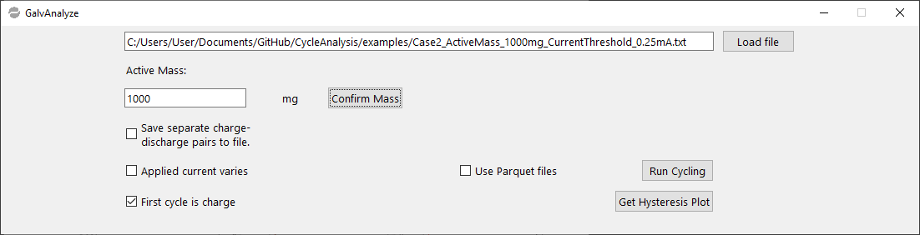
The procedure is the same as scenario 1 with respect to loading the file and entering the active mass. This will leave you with the following.

If you press the “Run Cycling” button at this point, the plots shown below will be generated along with a diagnostic plot that allows you to examine your data, applied thresholds, and regions marked as belonging to a charge (green) or discharge (red) process, as discussed in scenario 1.

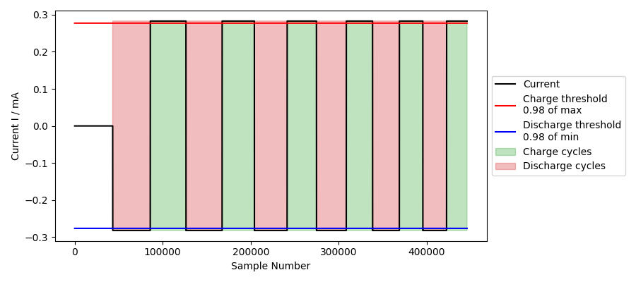
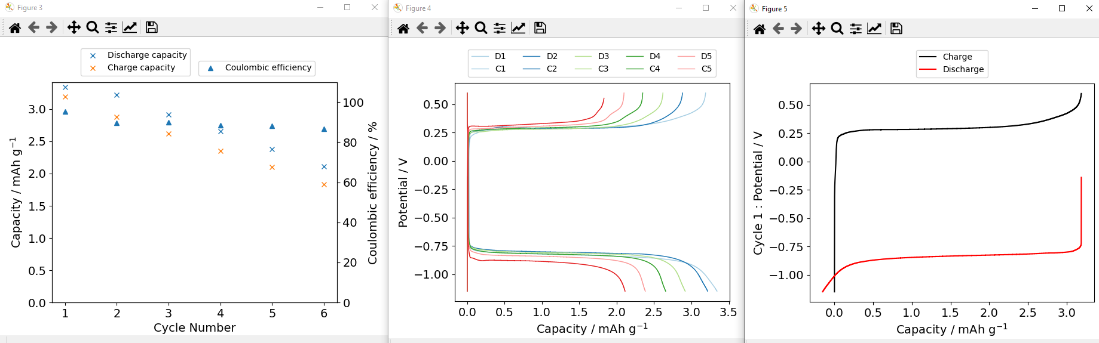

This data has been processes incorrectly, evidenced by the abnormal hysteresis plot. This is because the first process of this dataset is a charge process. There, you must deselect the “First cycle is charge” box, leaving you with a user interface as shown below.

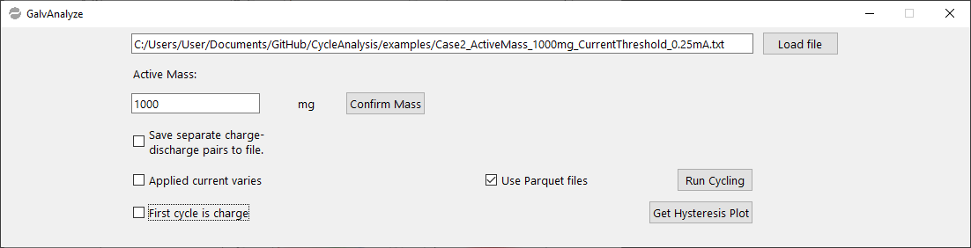

Now if you press the “Run Cycling” button, the data outputs are correct, as shown below.

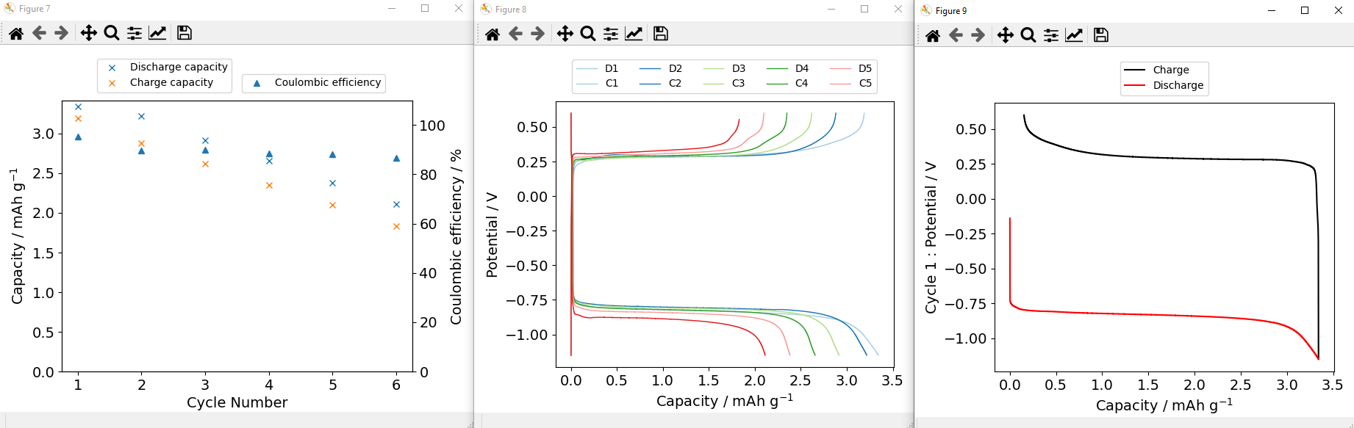

Scenario 3: Applied current varies
If there are changes in the applied magnitude of the current throughout your dataset, functionality has been built into the GalvAnalyze executable in the form of an “Applied current varies” tick box to accommodate for this. “Case1_ActiveMass_18mg_CurrentThreshold_0.15mA” will be used for this scenario, where a slower current was applied for the first two cycles than for the remaining 48 cycles.

The procedure is the same as scenario 1 with respect to loading the file and entering the active mass. This will leave you with the following. From the diagnostic plots, it is clear that the base threshold misses the first two cycles.

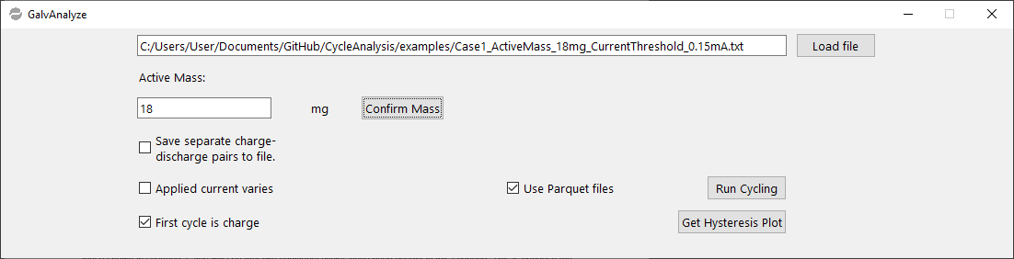

By selecting the “Applied current varies” box before pressing “Run Cycling”, you will be prompted to enter a current threshold. The authors suggest a current threshold of approximately 90% of your minimum applied current value. For this dataset, although the magnitude of the current is 1.69 mA for the majority of the dataset, the minimum applied current is 0.169 mA, so we have selected a current threshold of 0.15 mA.

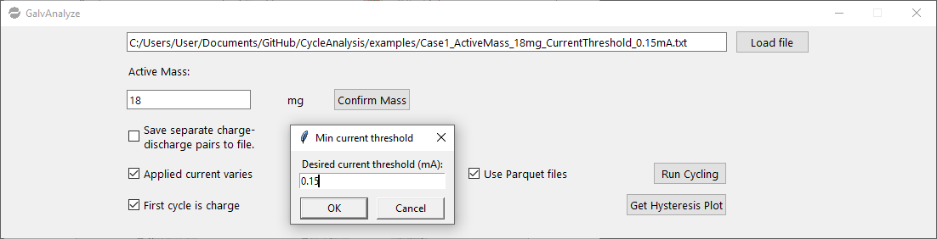

Press “OK” to confirm the current threshold and the executable will output the plots below. If you compare these plots to those shown in scenario 1, you will see that two additional cycles have been caught in this scenario. This is because the base functionality thresholding takes 95% of the maximum measured current, so is unsuitable for analysis of datasets where the current will vary by more than this limit.

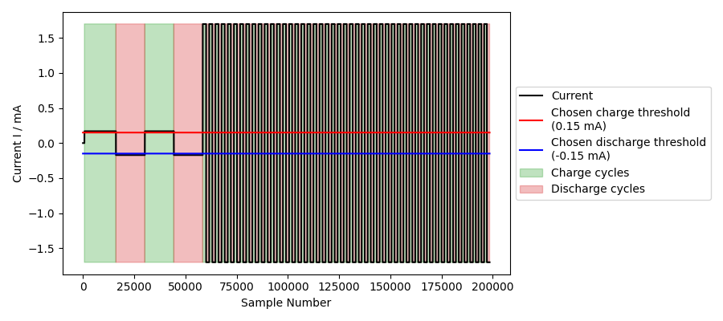
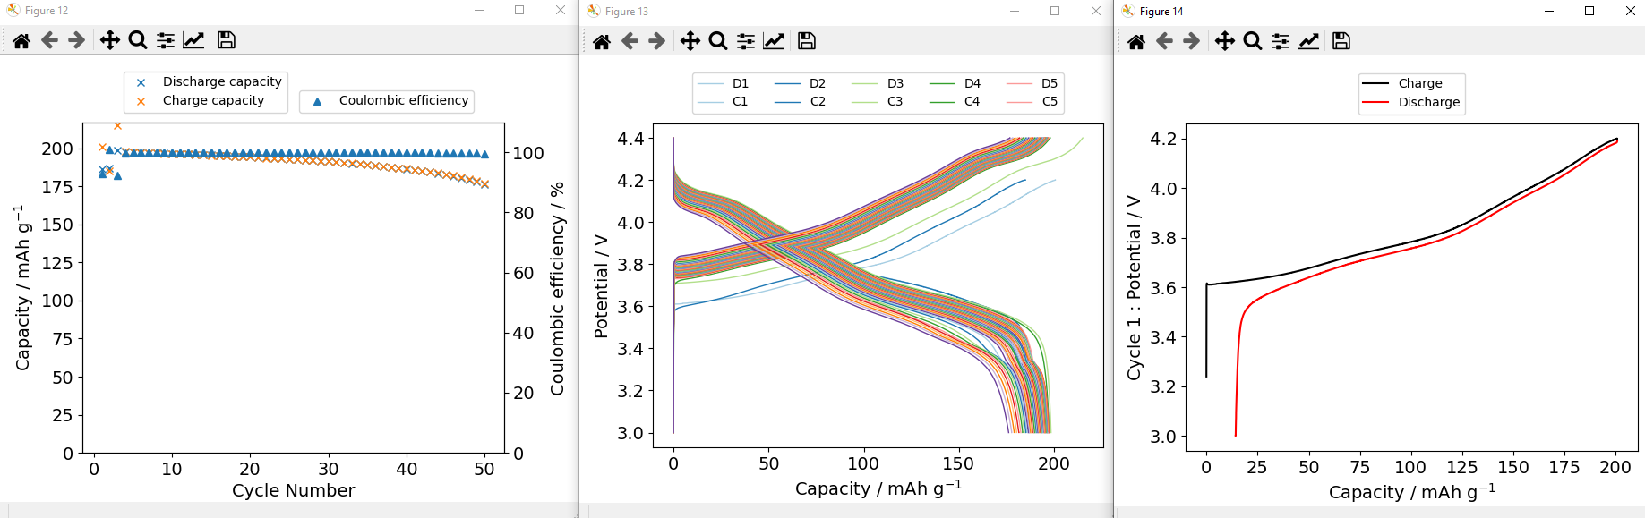

Furthermore, by examining the output diagnostic plot, it is clear that the new user defined applied current threshold now catches the first two cycles of the dataset.

Scenario 4: Exporting individual cycles
With datasets that require further workup, it is often useful to have each of the individual charge-discharge pairs saved as individual cycles. Functionality has been built into the GalvAnalyze executable in the form of a “Separate charge-discharge pairs to .csv” tick box. This scenario will use test case “Case2_ActiveMass_1000mg_CurrentThreshold_0.25mA”.

This scenario uses the same procedure in scenario 2 to ensure that the executable understands that the first process is a discharge process. At the start of this scenario, our user interface should be as shown below, with “First cycle is charge” deselected.

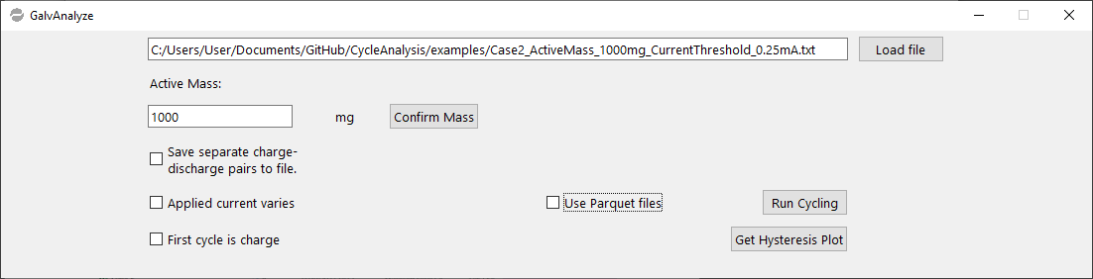

The “Separate charge-discharge pairs to .csv” box should then be ticked before pressing the “Run Cycling” button, as shown below.

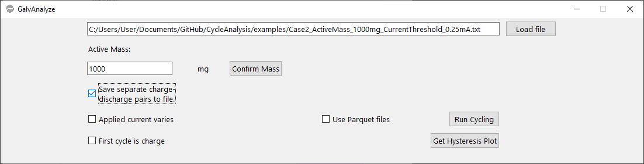

This will export the data as shown in scenario 2, with an additional folder “Individual cycles” which will contain each of the charge-discharge pairs separated into individual .csv files as shown below.
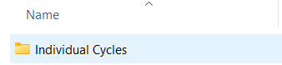
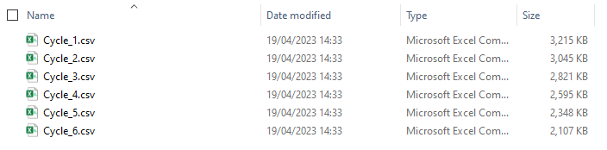
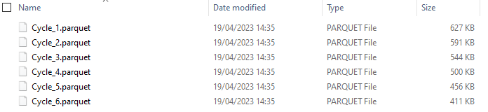
Alternatively, ticking the “Use Parquet files” box before clicking “Run Cycling” results in the following outputs:

Scenario 5: Exporting cycle specific hysteresis plots
Functionality has been built into the GalvAnalyze executable in the form of a “Get Hysteresis Plot” tick box to enable users to produce hysteresis plots of individual cycles. In order to use this functionality, ‘Scenario 4’ must have been carried out on the original dataset.

Once the individual cycles have been exported, use the “Get Hysteresis Plot” button in the executable to select the individual cycle that you would like to plot a hysteresis of. This will generate a graphic of the chosen cycle, saving the image as a .png file in the “Individual cycles” folder and a corresponding .csv file named “Cycle [x] Hysteresis”.

The below graphics show an example of this carried out for the cycle 4 of the test case “Case2_ActiveMass_1000mg_CurrentThreshold_0.25mA”.

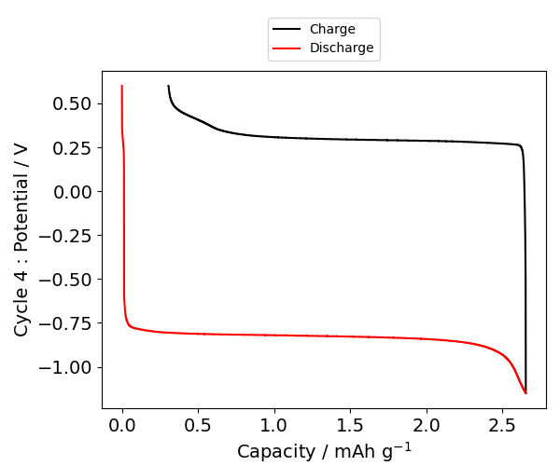
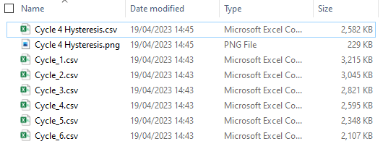
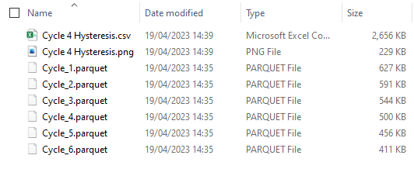

Operating systems
The executable provided at https://www.thenamilab.com/about-4 has been tested on Windows 10 and 11. The python source code is platform independent.
Programming language
Python 3.7 and above.
Additional system requirements
The pathlength of selected files is limited by windows at 260 characters. A common error is the pathlength is too long. To circumvent this error, we recommend that a portable hard drive or USB stick is used for data processing with GalvAnalyze.
Dependencies
List of required libraries if accessing from GitHub. All required dependencies are packaged into the executable file.
Software location
Website
Name: Nottingham Applied Materials and Interfaces website
https://www.thenamilab.com/about-4
Code repository
Name: GitHub repository
https://github.com/LukasRier/GalvAnalyze
Language
All documentation is provided in English. For a translation into another language, contact the corresponding author.
Error handling and submission of feedback, improvements, and requests for new functionality
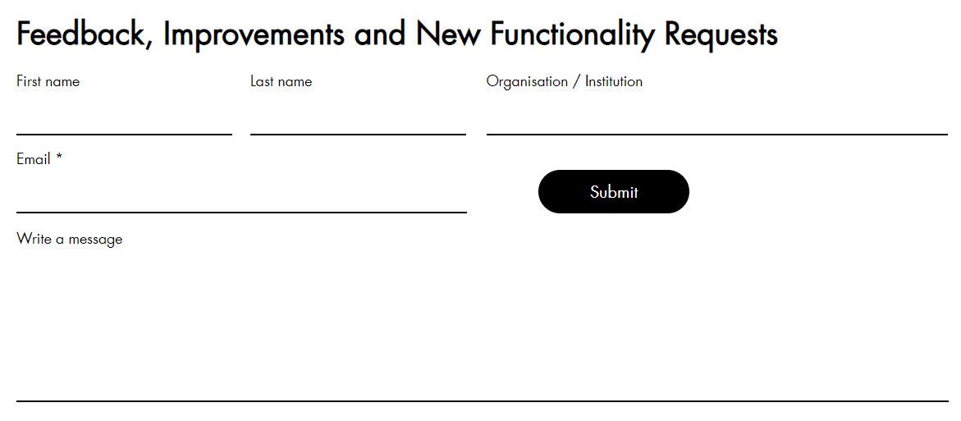
There are cases where data will be incompatible with the GalvAnalyze tool and processing will fail as a result. To enable the user to understand why the process has failed, a log is exported each time a dataset is run using the tool. A set of scenarios where GalvAnalyze fails are shown below. If you experience any of these, or any other, issues, please do not hesitate to get in touch with the authors by filling in the form hosted at https://www.thenamilab.com/about-4 and shown below. Furthermore, if you have any improvements or requests for additional functionality, please submit these using this form.
Error scenario 1: Incorrect column headings
GalvAnalyze is programmed to accept the following column headings:
Potential: “Ecell/V”, “E /V”, “Ewe/V”, “E/V”, “Voltage/V” or “Voltage(V)”
Current: “<I>/mA”, “I /mA”, “I/mA”, “Current/mA”, or “Current(A)”
Time: “time/s” or “time /s”
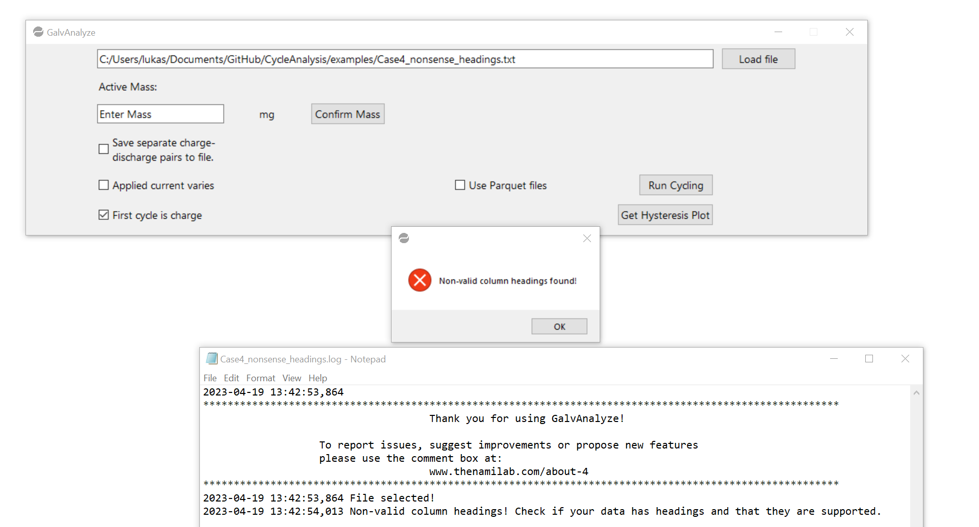
If a file is selected that does not contain column headings with these values, the tool will fail and an error message saying “Non-valid column headings found!” will be displayed. An example GalvAnalyze user interface, error message and the log file, which is exported every time a file is loaded into the user interface, are shown below.
To address this in the short-term, alter the column headings to match one of the options listed above. Please also submit an improvement request at https://www.thenamilab.com/about-4 and we will update the source code to be compatible with your specific data requirements to avoid you having to do this in the future.
Error scenario 2: File is empty
If the file loaded into GalvAnalyze contains no data (i.e. a blank text file), when the executable is run an error message that reads “No data found in the file.” will be displayed as shown below. The log file, which is exported every time a file is loaded into the user interface, will also contain details of the error
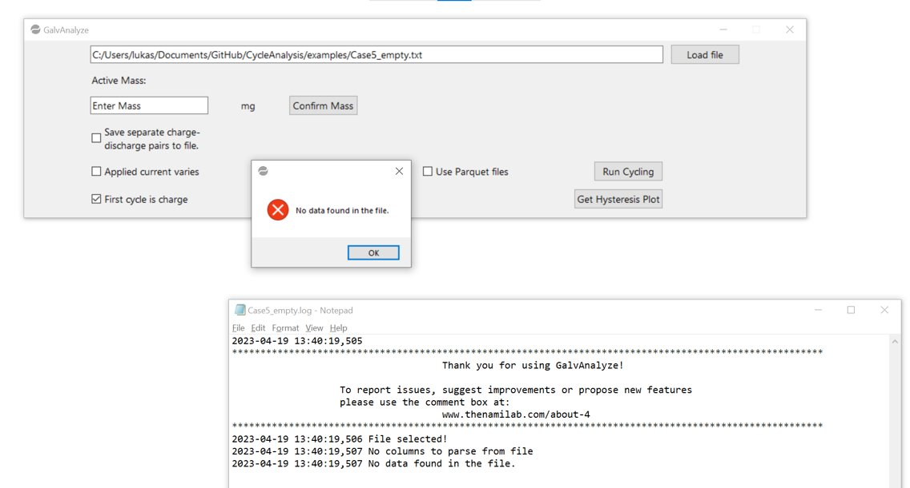

In this case, either the wrong file has been selected, or the data has been exported wrong from the battery cycler. Please re-export your data and try again. If in doubt, open the input text file and check the contents manually.
Error scenario 3: Data cannot be read/no data in the columns
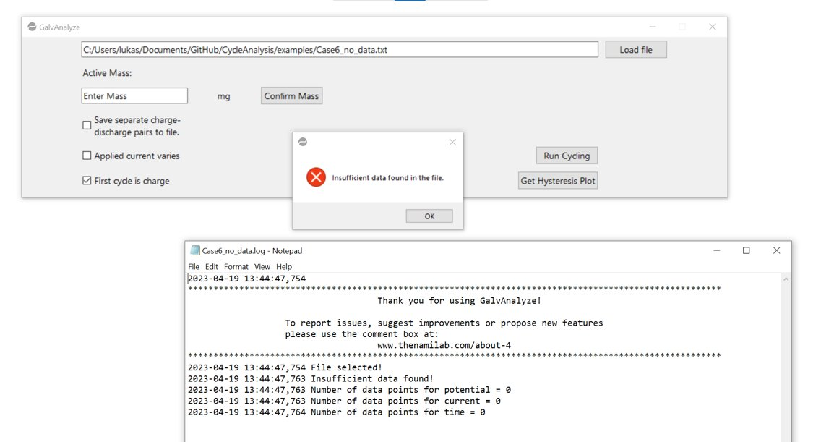
This error will occur when GalvAnalyze can read the column headings, but the data in the columns is not in a format that can be understood or further processed by the tool. In this case, an error message saying “Insufficient data found in the file.” will be displayed. An example of the outputs are shown below.
This means that there is a formatting error in the data and to address this, try re-exporting the data or looking for obvious errors. If this issue persists, please submit a query at https://www.thenamilab.com/about-4 and the authors will assist you where possible.
Error scenario 4: The data only contains a single charge or discharge
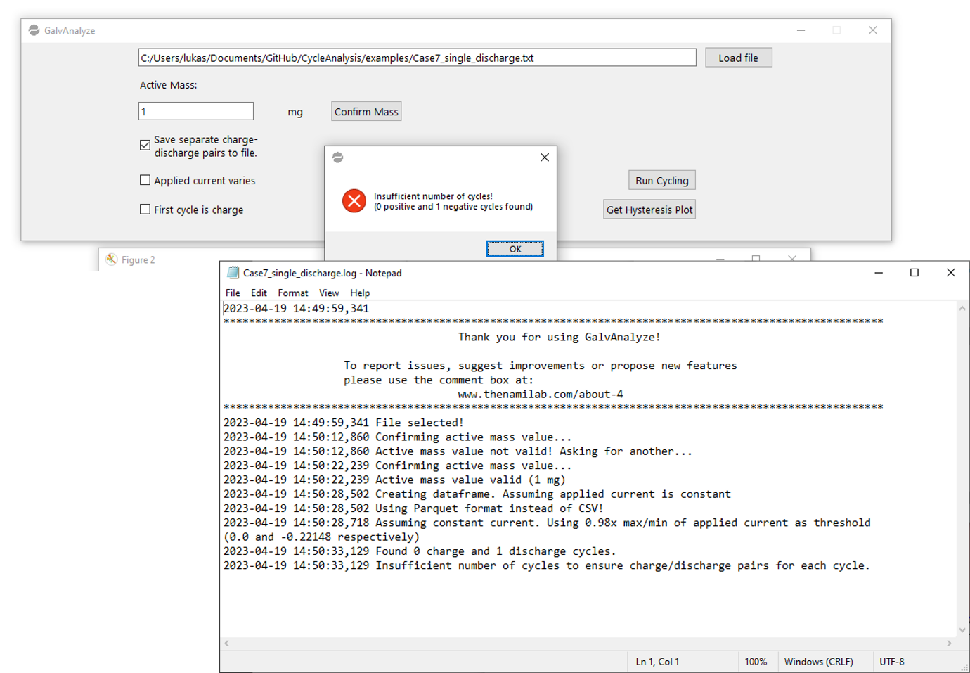
This error will occur when GalvAnalyze successfully reads the data, however, there are no ‘pairs’ of charges and discharged (i.e. it counts 0 cycles). In this case, GalvAnalyze will fail and an error message saying “Insufficient number of cycles! (X positive and Y negative cycles found)”, where X and Y are numbers ≤1 one of which is 0. This error will also be shown in the log file that is exported.

GalvAnalyze can only handle datasets with at least 1 cycle. If you data contains only one (dis)charge process, then it is not compatible with this executable at this time. It you see considerable benefit from enabling this functionality, please submit a query at https://www.thenamilab.com/about-4.

